 FUT Document 

Rebate Amount Override

Business Problem

In certain business scenarios, a customer may not achieve the predefined sales target based on their actual sales performance at a specific point in time. However, additional commercial flexibility to maintain customer relationships, encourage future growth, and protect long-term business value.

Proposed Solution

The proposed solution will allow authorized users to Override the Rebate Amount for selected priority customers. This will help the business manage special customer situations while maintaining the standard target and rebate process.

The adjustment should be controlled through proper authorization and approval rules to ensure transparency and prevent misuse.

User Process
Rebate Amount Override & Approval Flow – Overview
Override: It refers to the process of directly modifying the Rebate Amount in the tracking document when the customer does not receive the expected incentive based on actual sales, irrespective of the system-calculated incentive amount. Both capabilities provide the business with controlled flexibility to address specific customer and commercial requirements.
Approval Flow: Approval Flow is the process used to review and authorize a Rebate Amount that has been overridden manually. Once the Override File is uploaded, the system refreshes the Settlement Tracking and adjusts the rebate amount based on the uploaded override value. The adjusted amount is then routed through a three-level approval process. Each approval level reviews and approves the overridden rebate amount. Only after all three levels of approval are completed, the approved override amount becomes eligible for payment.

FUT Document

Contents
Step 1: Create Master Agreement ...................................................................................................................................... 3
Step 1.1: Maintain Master Agreement Details.................................................................................................................. 3
1.1.2: Maintain Eligible Customer ........................................................................................................................... 4
1.1.3: Create Sub-Agreement ....................................................................................................................................... 4
1.1.4: Maintain General Data ........................................................................................................................................ 5
Step 1.2: Maintain Eligibility ............................................................................................................................................. 5
1.2.1: Maintain Eligible Source ......................................................................................................................................5
1.2.2: Maintain Flexible Group .......................................................................................................................................6
1.2.3: Select Line Type ..................................................................................................................................................6
Step 1.3: Maintain Eligible Product Grouping ...................................................................................................................7
Step 1.4: Maintain Benefits and Accrual Rates ................................................................................................................8
Step 1.5: Submit for Approval ..............................................................................................................................................8
Step 2: Accrual & Settlement Tracking ...............................................................................................................................9
Step 2.1: Run Accrual Tracking .......................................................................................................................................9
Step 2.2: Run Settlement Tracking ..................................................................................................................................9
Step 2.3: Upload Adjustment Override File .....................................................................................................................10
2.3.1: Maintain Override File Details ............................................................................................................................10
2.3.2: Create Submission .............................................................................................................................................11
2.3.3: Upload File .........................................................................................................................................................11
Step 2.4: Update Settlement Tracking ............................................................................................................................12
2.4.1: Verify Override Amount ......................................................................................................................................12
2.4.2: Submit for Approval ............................................................................................................................................12
2.4.3: Complete Approval ...............................................................................................................................................12
Step 3: Generate Payment .................................................................................................................................................12
Step 3.1: Open Outgoing Payments – Settlement ...........................................................................................................12
3.1.1: Set Payment to Ready .......................................................... ……………………………………………………….13
3.1.2: Generate Payment File .......................................................................................................................................13
Step 3.2: Verify Payment File ............................................................................................................................................13
Remarks ...............................................................................................................................................................................14

FUT Document

Create Master Agreement

1: Navigate to Off Invoice Rebates click on Master Agreements tile.
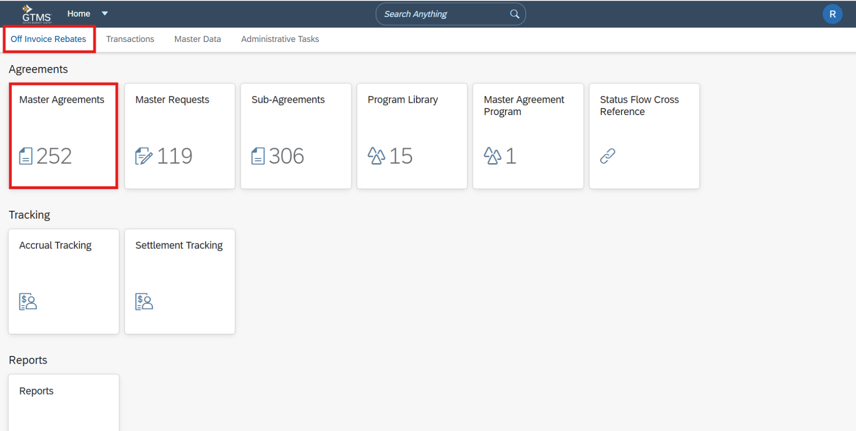
1.1: Create a new Master Agreement, Maintain Agreement Description, Business Unit, Validity Period, and other mandatory fields.
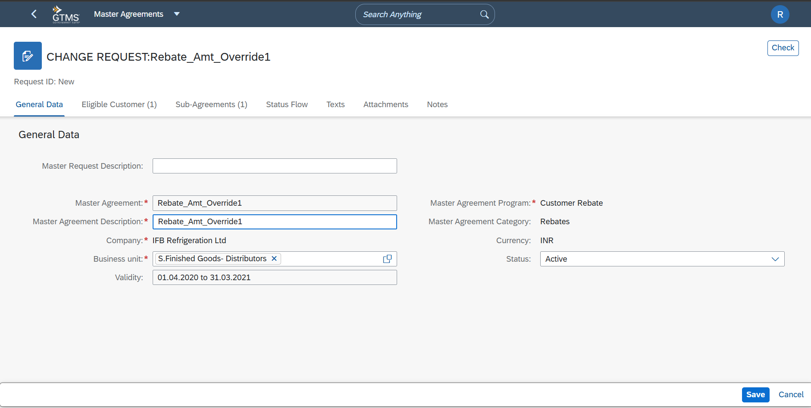

FUT Document

Maintain Eligible Customer
1.1.2: Navigate to the Eligible Customer tab, Click the (+) Add icon and select the applicable customer.
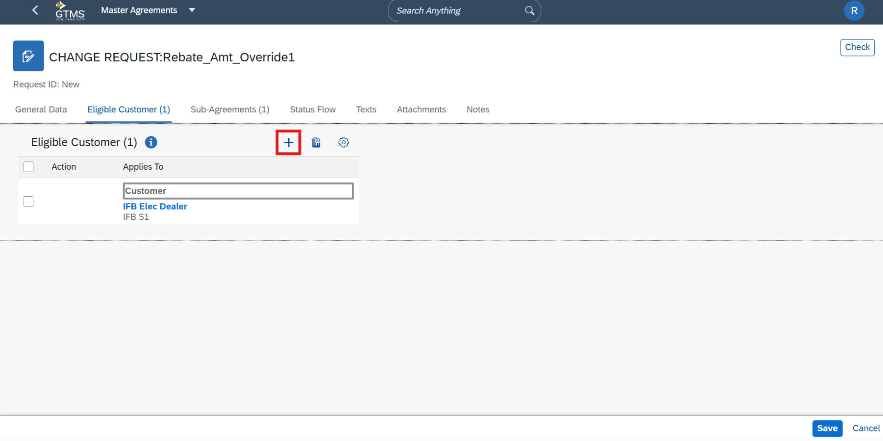

Create Sub-Agreement
1.1.3: Navigate to the Sub-Agreements tab, click on Create select the required Sub-Agreement Program and maintain Validity, Period Profile, Accrual Frequency, and Settlement Frequency. Click on Arrow to drilldown the sub-agreement.
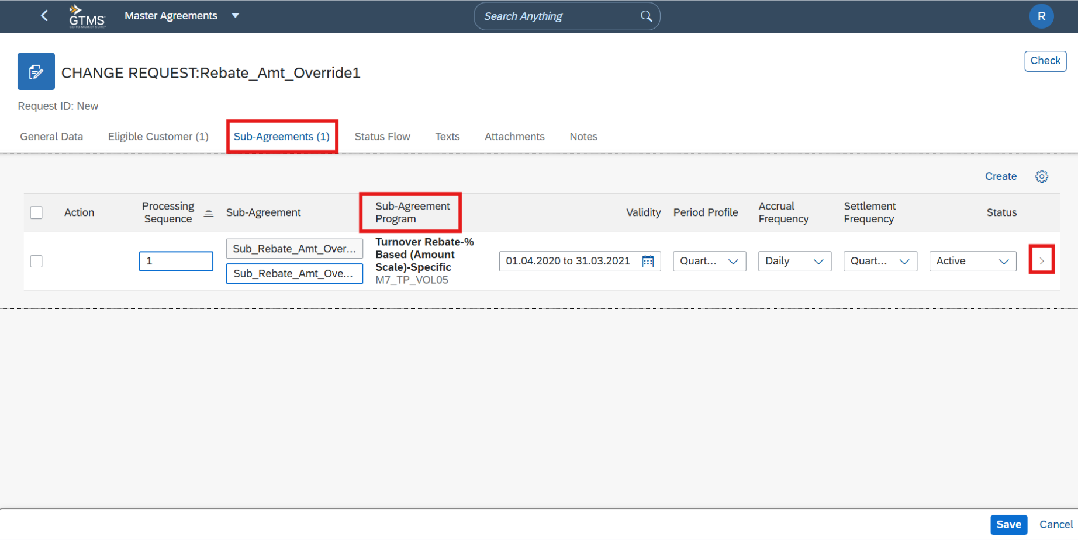
FUT Document

1.1.4: Maintain General Data, which defines GST Indicator and Key for Prov G/L.
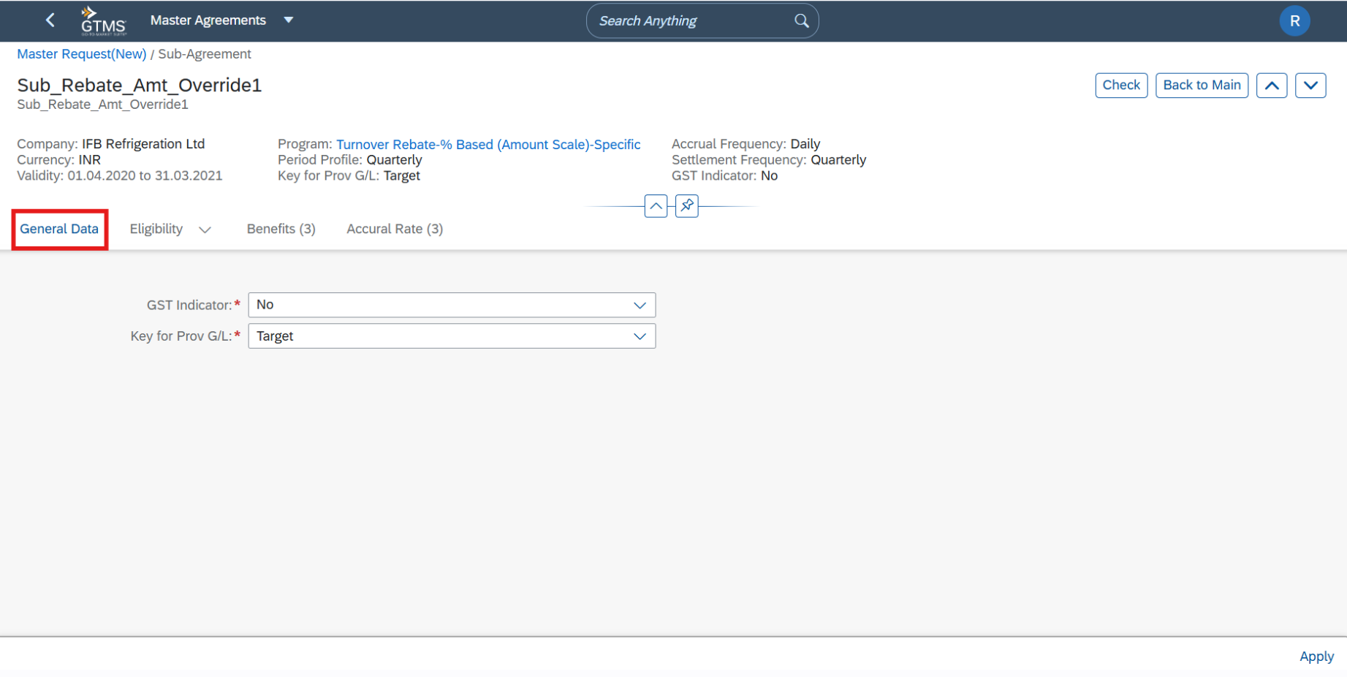
Eligibility
1.2.1: Navigate to the Eligibility tab, Under Sources, click the (+) Add icon and maintain the Eligible Source as required.
1.2.2: Create a new Source named Rebate Amount Override, Choose Adjustment from the dropdown list.
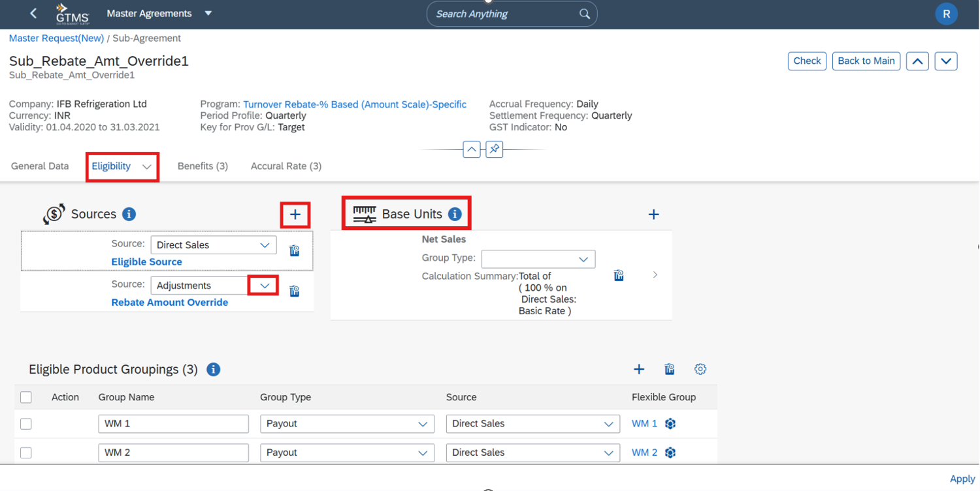

FUT Document

Click on Flexible Group.
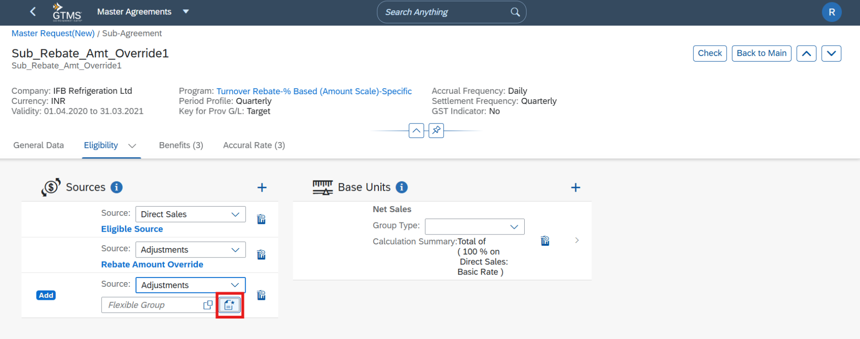

1.2.3: Maintain description and Choose Line Type from the dropdown list. Open the Line Type selection window.
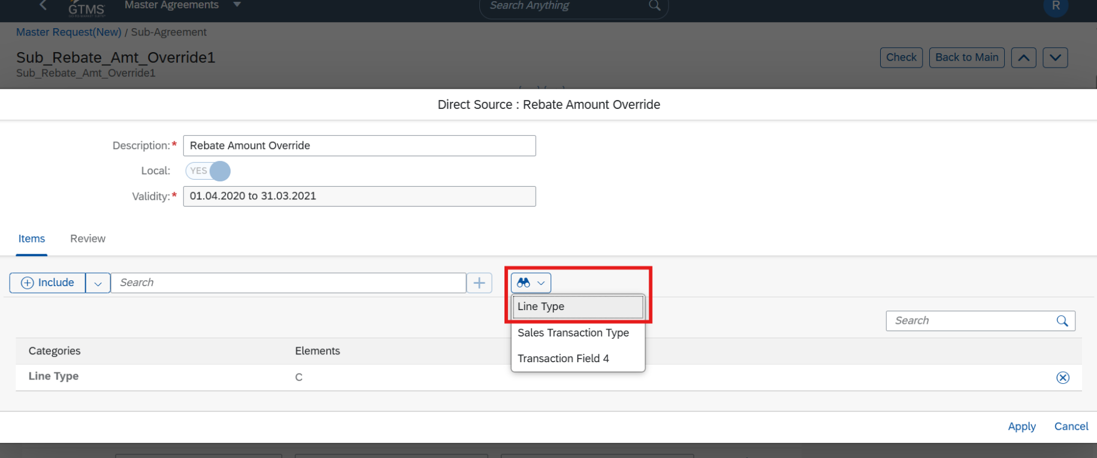

FUT Document

1.2.4: Select Rebate Amount Override, Confirm the selection then it return to the Eligibility screen.
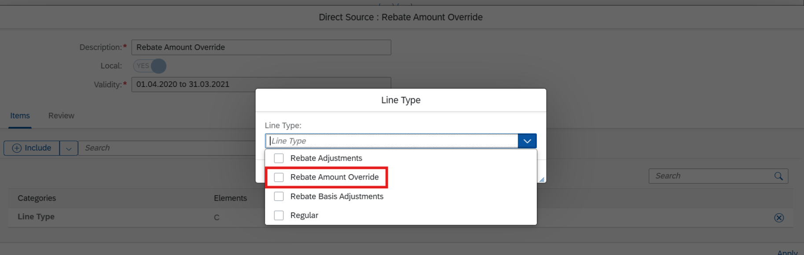

Maintain Eligible Product grouping
1.3: Click on Add (+) and maintain product grouping.
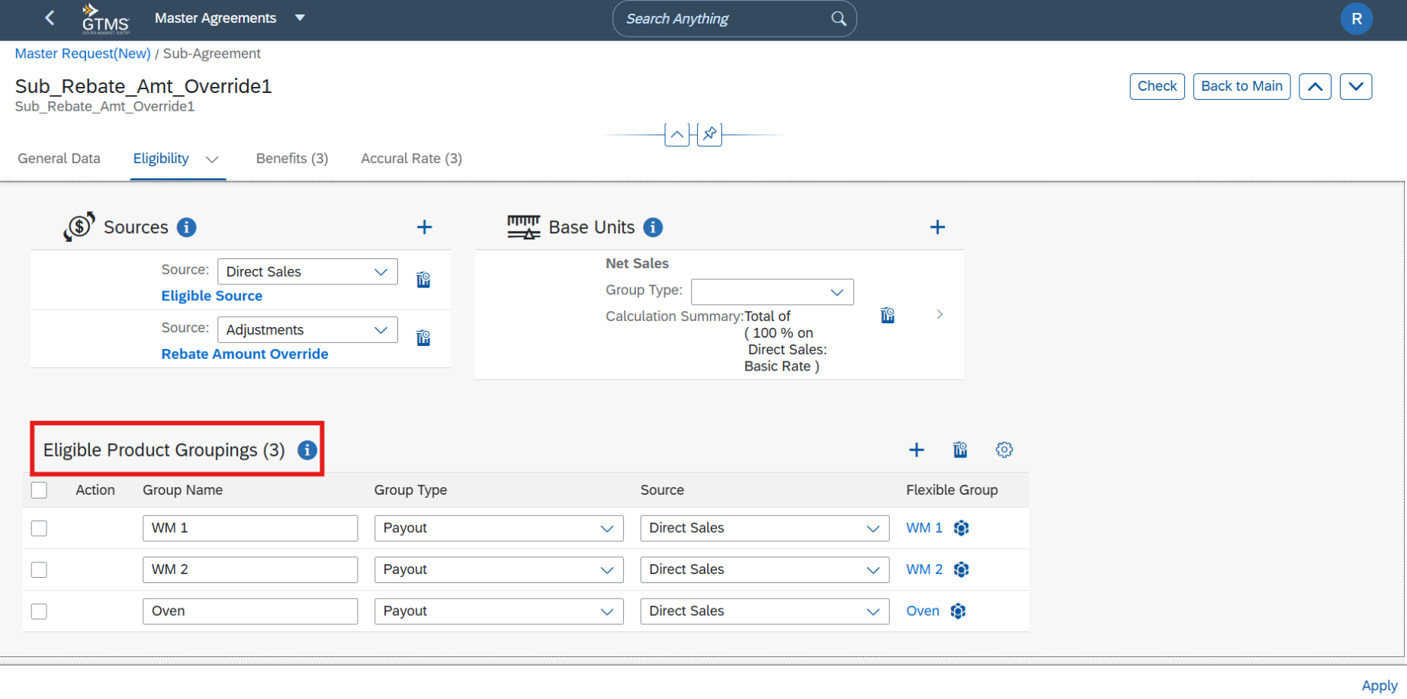

FUT Document

Maintain Benefits and Accrual Rates
1.4: Navigate to the Benefits tab, Maintain the required payout group, benefit scales and rebate percentages.
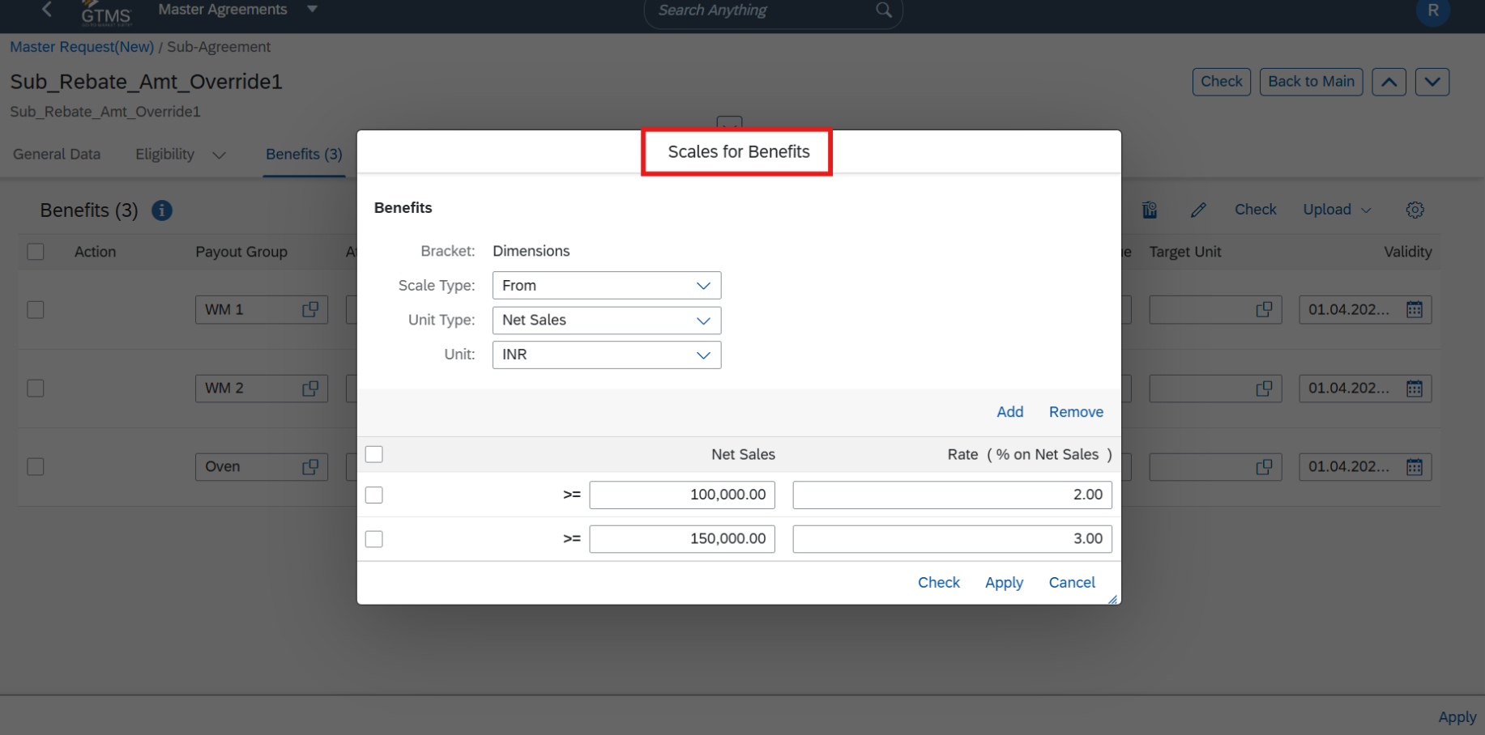

1.4.1: Navigate to the Accrual Rate tab, Maintain accrual percentages for each payout group, then Click on Apply.
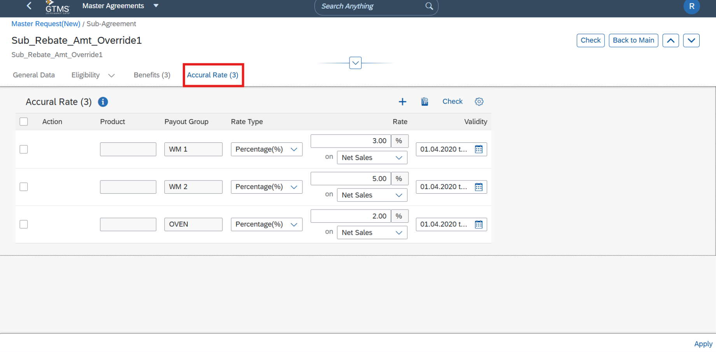

FUT Document

Submit for Approval
1.5: Click on Save then Submit, Click Approve to complete the approval process.
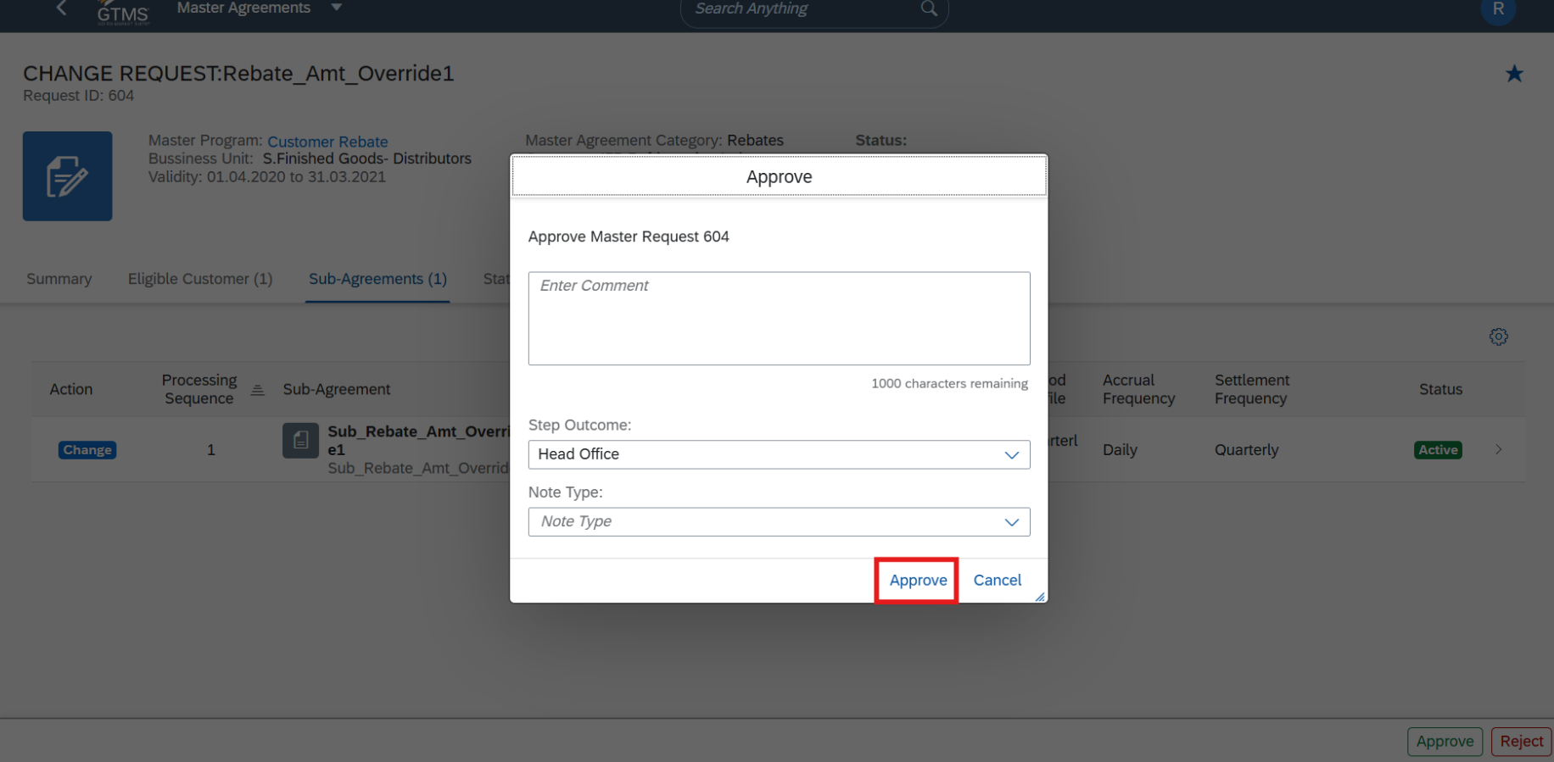

Accrual & Settlement Tracking
2: Navigate to Off Invoice Rebates click on Work Manager in Admin Actives.
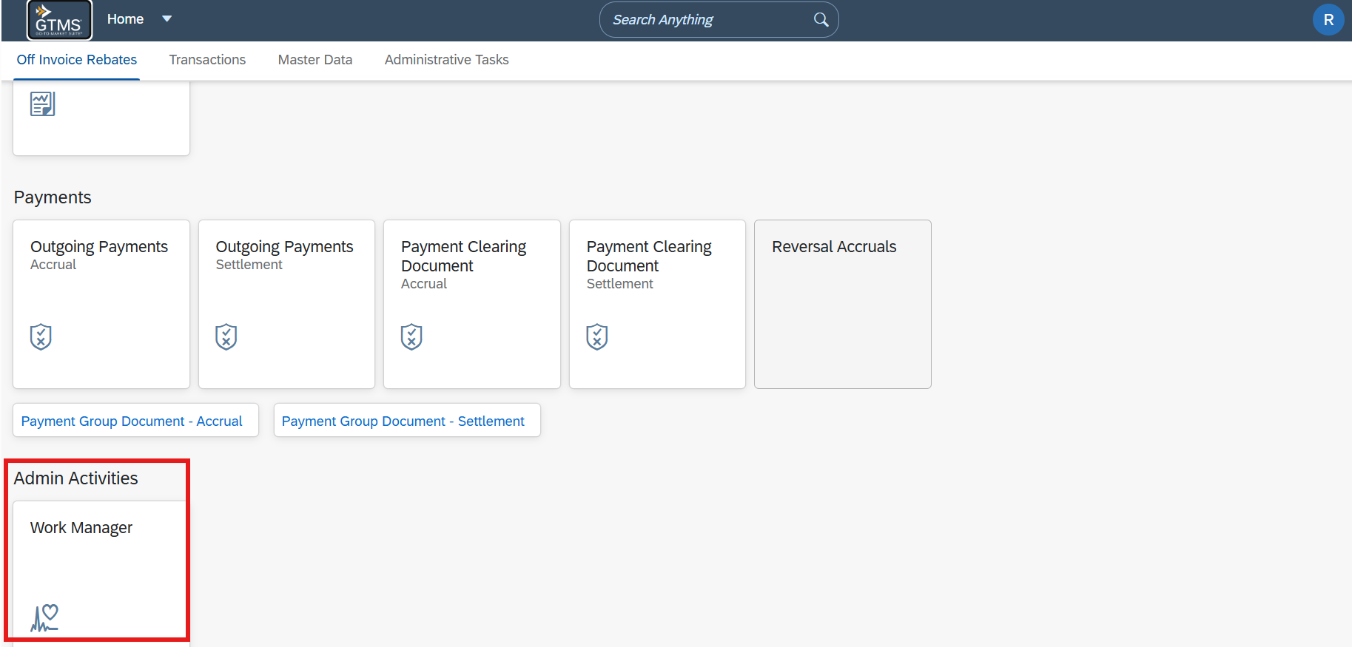

FUT Document

2.1: Select the relevant tracking to schedule.
2.2: Once the Accrual Tracking run and Posted, Then run settlement tracking according to settlement frequency.
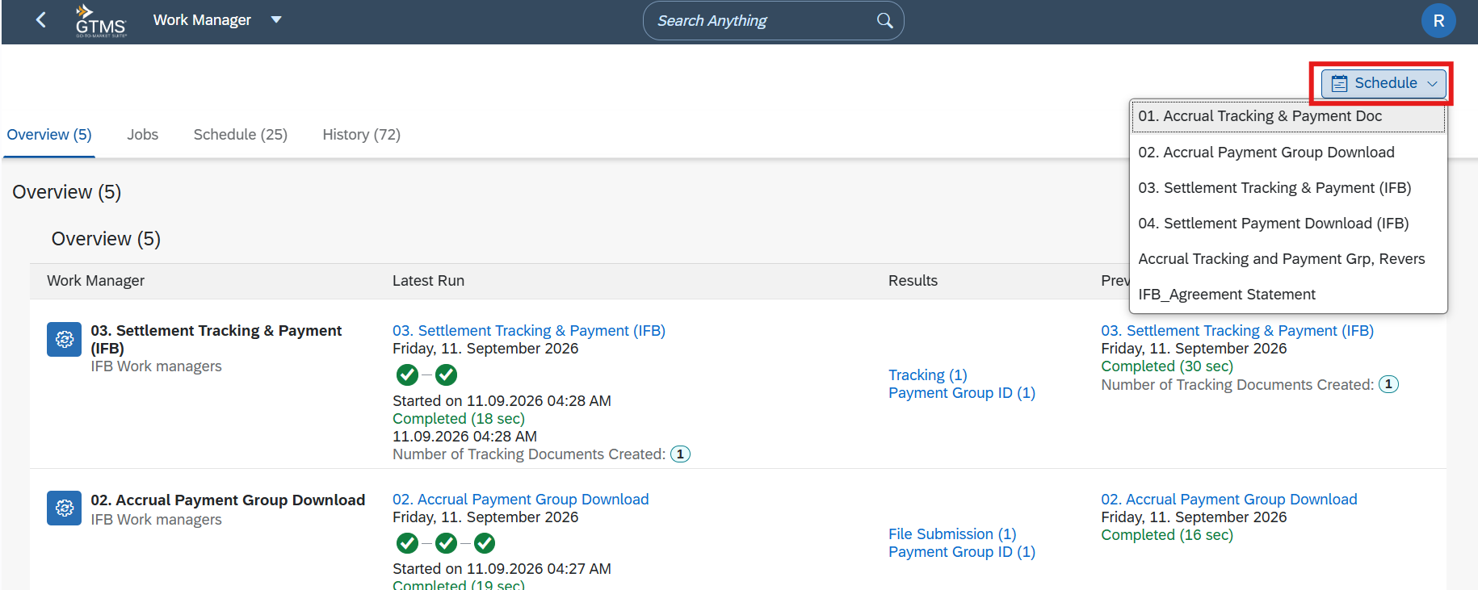

2.3: Go to Administrative Task click on Submission log tile. (Separate Tile will be Added in uploaded)
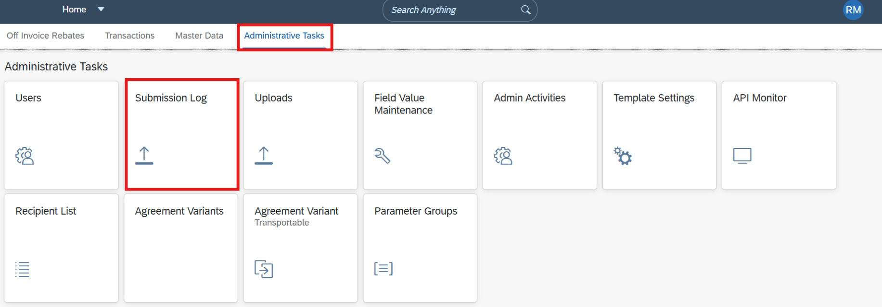

FUT Document

2.3.1: Upload the Adjustment Override file in the required format:
- Adjustment Override ID
- Sub Agreement
- Sales Organization
- Distribution Channel
- Customer
- Tracking Date
- Override Amount (Net Value)
- File link : MXAD - Rebate Amount Adjustments_Sample File.csv
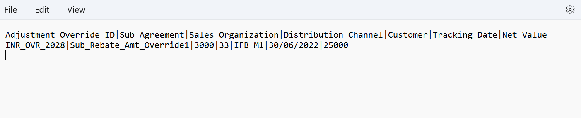

2.3.2: Click on Create, Enter (SA – Rebate Amount Adjustment).
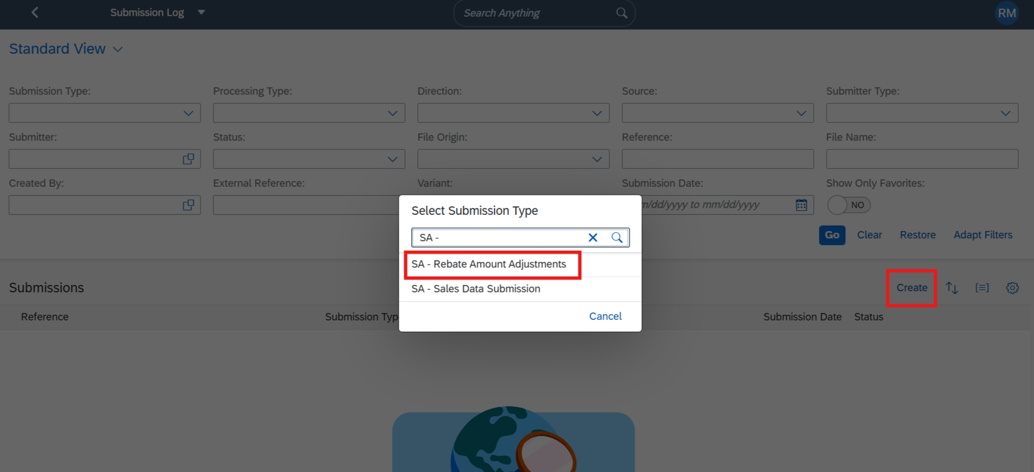

FUT Document

2.3.3: Click on Browse to upload Adjustment Override file, Click on submit.
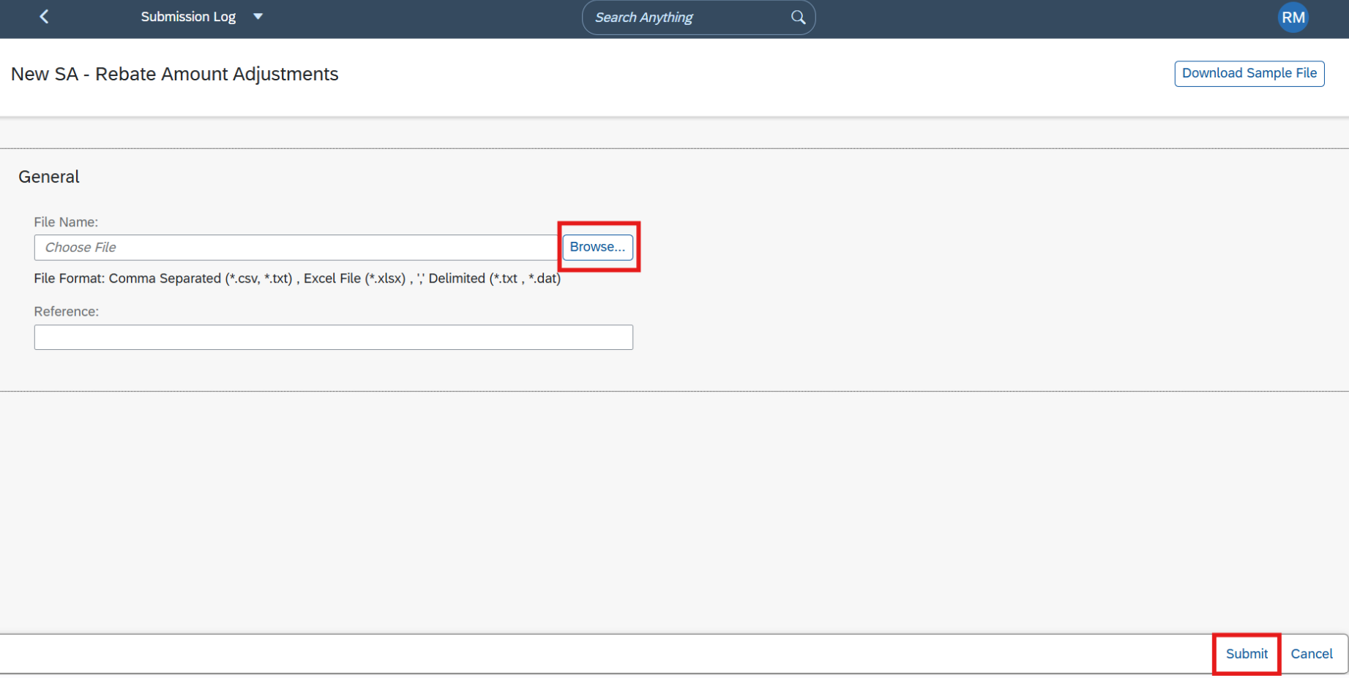

2.4.1: Once Adjustment Override file uploaded, Run Settlement tracking according to the maintained settlement frequency.
2.4.2: Rebate Amount Override will be updated, Also confirm the updated Total Amount and Cumulative Total.
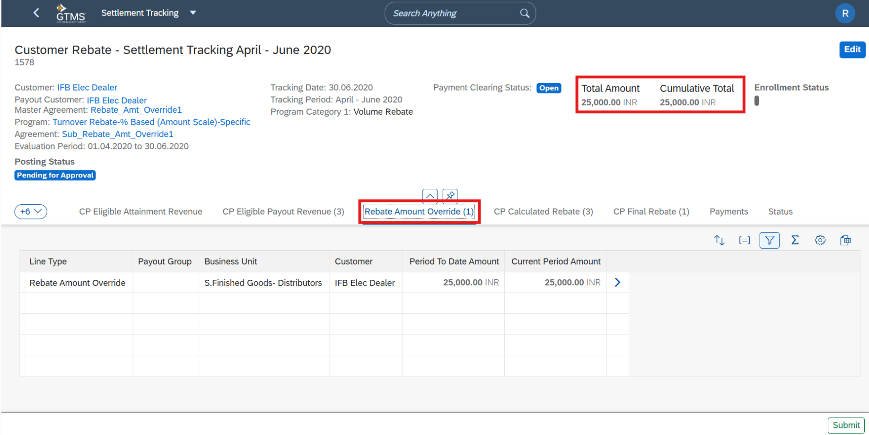

FUT Document

2.4.3: Submit the document for approval.
2.4.4: Click Approve, Complete all approval levels.
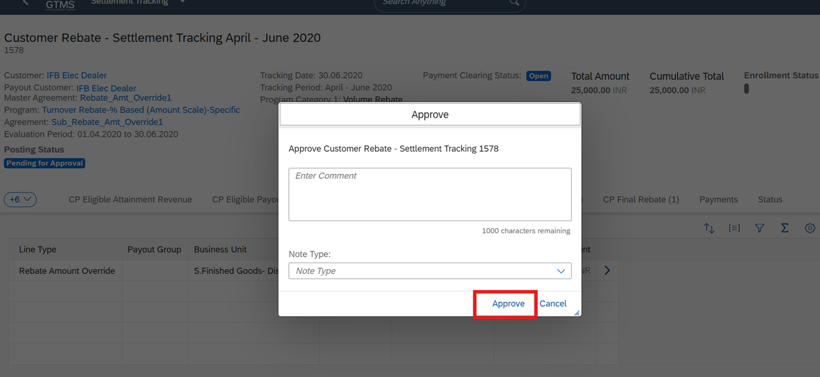

Generate Payment
3.1: Open Outgoing Payments Settlement tile.
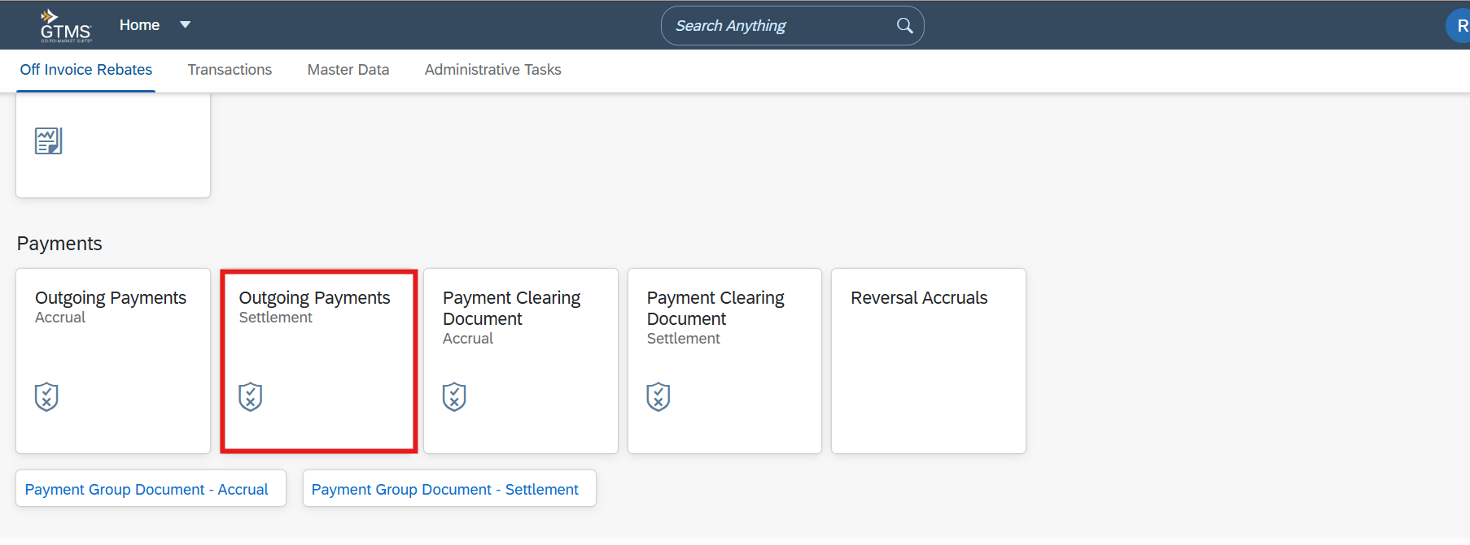

FUT Document

3.1.1: Select the applicable Payment Group, enable Multiselect Click Set to Ready for Payment then click Save.
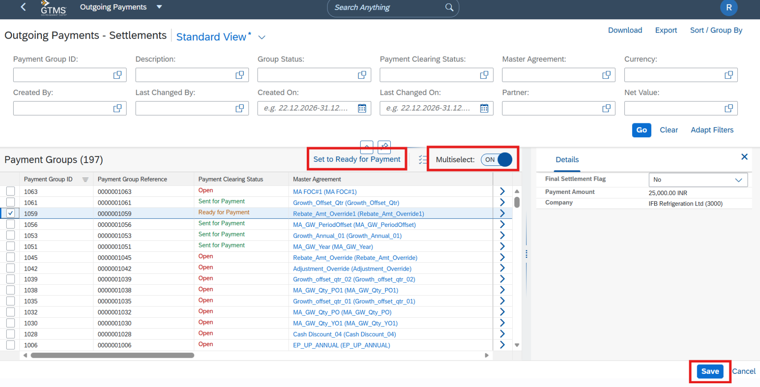

3.1.2: Navigate to Work Manager, Run Settlement Payment Download, Verify successful payment file generation.
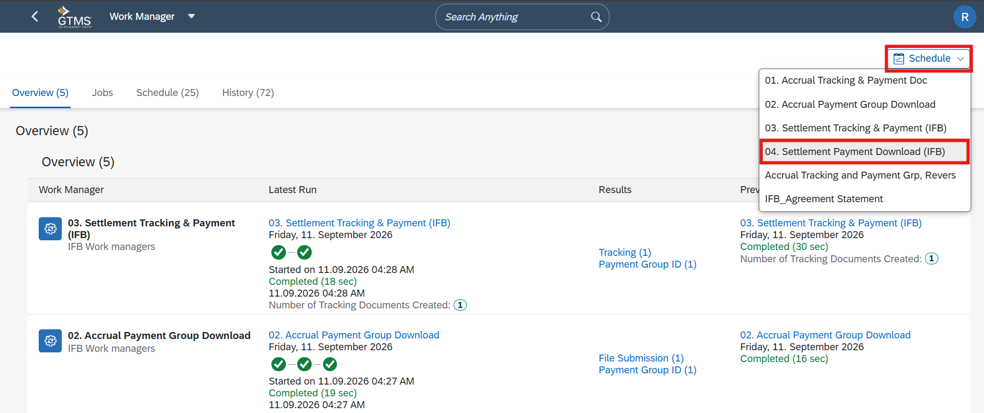

Remarks:
Rebate Amount Override process was successfully validated end-to-end. Override amount was correctly updated in Settlement Tracking, processed through the approval flow, and successfully progressed to payment.

